Reflection Questions for Session 1 – Jesus Christ

Reflection Questions for Session 4 – Service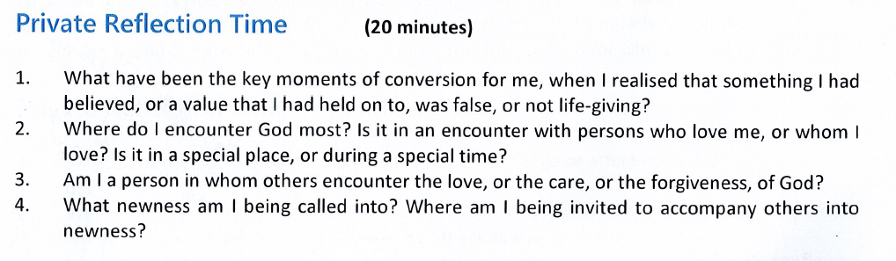

Reflection Questions for Session 3 – Witness

Reflection Questions for Session 2 – Evangelisataion

