IMAGINATIVE PRAYER FOR FAMILIES
Imaginative prayer acknowledges the gift and the power of the Holy Spirit at work in each of us to bring about a deeper knowledge of God and a greater closeness to the author of all life and being.
There are four basic steps in the process:
- RELAX
- FOCUS
- PONDER
- PRAY
STEP 1: Successful imaginative prayer requires children to be alert but relaxed. This can be achieved by introducing a relaxation routine through listening and breathing exercises. Music can be playing quietly in the background.
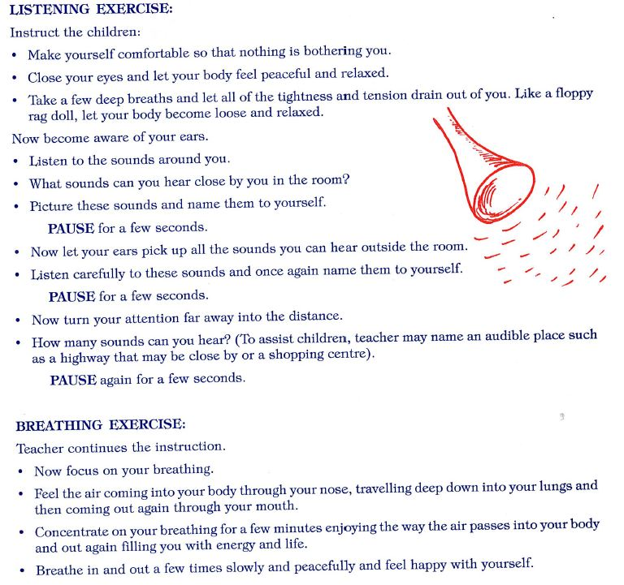

STEP 2: Choose a concrete object – it can be a household object or an object from nature e.g. a stone, a leaf a toy etc. There is no limit as everything is a source of prayer and conversation with God to those who believe in God’s nearness and presence.
Attention is focused on a concrete object before them.
Parents lead the discussion
- Hold the object in your hands and look closely at it.
- What does it feel like? Is it rough, smooth etc.
- What can you see? What colours are present?
- Where do you think it came from?
- Do you have other objects like this?
- What do you like about your object?
STEP 3 : PONDER
In this step the children thoughts are directed to the association with the object.
Place the object in front of you and close your eyes and think about these questions.
- When you think about your …….. what does it remind you of?
- Does it remind you of someone you love?
- Does it tell you something about God?
- Does it tell you something about yourself etc.
STEP 4: PRAY
This is the main part of the meditation
Children are encouraged to:
- Enter their heart or special place in their imagination where they can talk with Jesus using the object as a theme for the prayer;
- Share with Jesus their personal thoughts and feelings about the object of the meditation or anything else they may wish to share with him;
- Listen to what Jesus might say to them in reply.
- PAUSE for a few seconds.
Gently bring the children back to the present by using the breathing exercises outlined above.
(Adapted from Barbara Ann Bretherton, 1995. Praying with children.)

